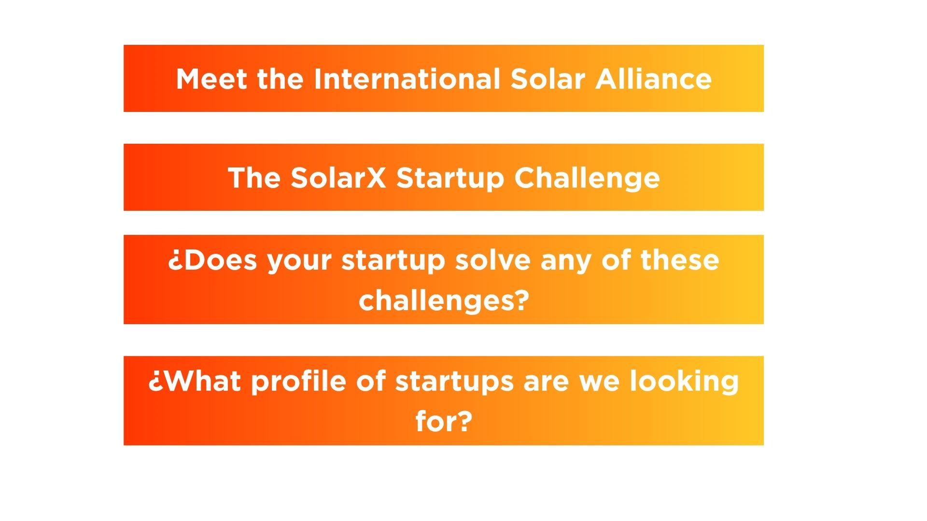

**Incubating the Next Generation of Solar Leaders**

The SolarX Startup Challenge is an initiative of The International Solar alliance that provides financial support, acceleration programs, and mentorship to entrepreneurs, opening pathways to investors and diverse markets. By driving innovation and fostering a vibrant startup ecosystem, the challenge transforms the solar sector, enabling solutions to scale across regions and contexts, reshaping the global energy landscape.

The first edition of the challenge was focused on the African region, expanding to APAC (including India) in 2024. The aim is to promote innovation and discover local solutions, with the overarching objective of capacity-building of stakeholders across the globe. The next edition of the Challenge will focus on the LAC Region in 2025, with the aim of building the solar energy sector in the region along with promoting startup and innovation culture in the local ecosystems.



**The ISA is a global intergovernmental organization dedicated to advancing solar power adoption for a carbon-neutral future**

The ISA is a collaborative initiative between India and France aimed at uniting efforts to combat climate change by implementing solar energy solutions. It was conceptualized on the side lines of COP21 in Paris in 2015. Following a 2020 amendment to its Framework Agreement, all UN member states are now eligible to join the Alliance. Currently, 100+ countries are signatories, with 90+ countries having ratified to become full members. Its mission is to unlock $1 trillion in solar investments by 2030 while reducing technology and financing costs.



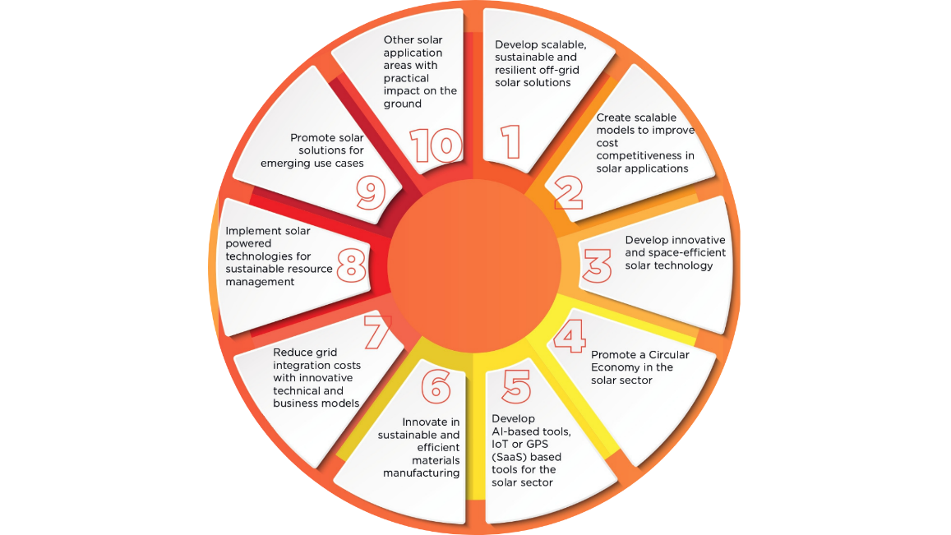

**Make sure your startup meets the following eligibility criteria:**

1. **You have a solar startup** that solves one or more of the challenges of the call.
2. **You have a Minimum Viable Product (MVP).** Business in the stage of idea or conceptualization, should not apply. A functional MVP, able to capture the value of market must be in place.
3. **Your startup may be incorporated Latin America and the Caribbean country members of ISA** or anywhere in the rest of the world. Preference will be given to entities working in the LAC region. We are looking for startups that create impact from and for the region. In case you have and mvp which doesn’t fit the LAC market, please still apply. The evaluation committee will see your case.
4. **Your startup has a maximum of 10 years from its registration date.** This means that the date on which the business was incorporated or registered, won’t exceed 10 years until the opening of applications on May 20th.

* The type of entity may either be:
* Private limited company
* Public company
* Corporation
* Limited liability partnership (LLP)
* Limited liability company (LLC)
* Cooperative
* Society
* Trust
* NGO
* Charitable entity
* Government entity
* Joint venture
* Any other entity

1. **Your startup may be implementable in the region as well.** We are looking for startups that create impact from and for the region. In case you have and mvp which doesn’t fit the LAC market, please still apply. The evaluation committee will see your case.
2. **You do not need to have a patent or copyrights to apply.**
3. **The startups will need to show revenue** but this doesn’t mean the entity should be profitable. Prove that you are trying to validate revenue models with sales to customers or running experiments.

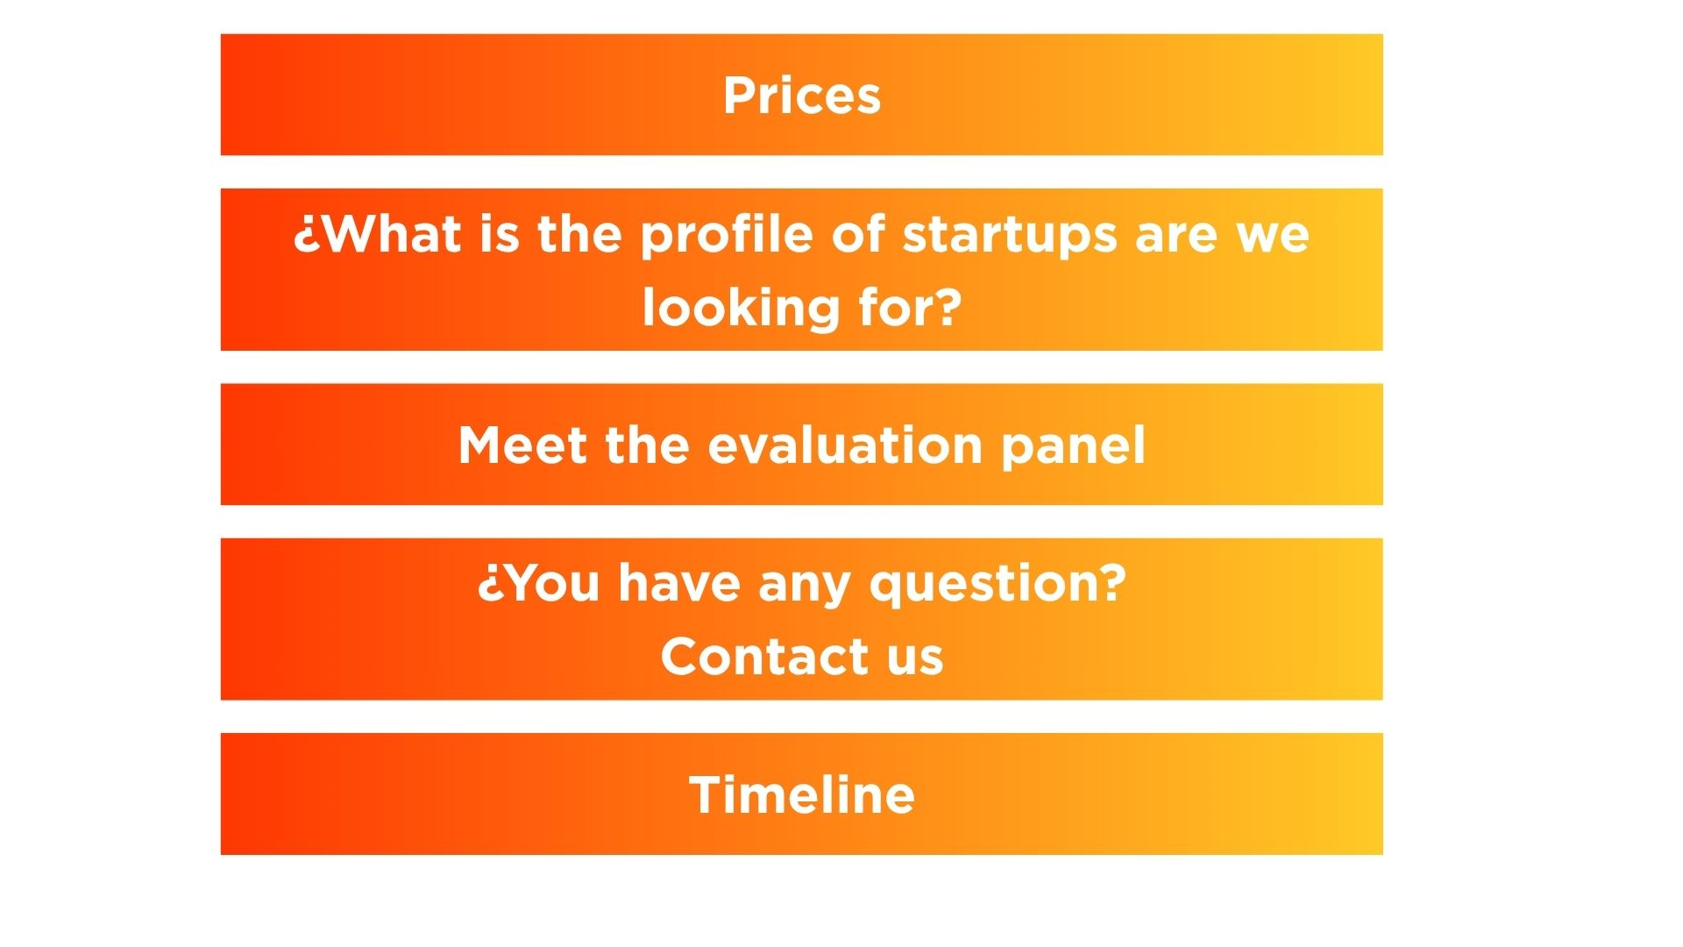

**We’re selecting 20 winning startups that will receive:**

* **$15,000 USD in cash grants**
* **Mentorship** **from industry leaders**. Winners will participate in training opportunities in business, technical, and human resources and management areas. This includes masterclasses given by experts on key topics and synergy opportunities among winners.
* **Market access opportunities** and investment connections.
* And a chance to be **announced at COP30 in Belém, Brazil\*** — global stage for climate innovation.

*The organizers will not provide any benefit not explicitly stated on this document. The partner organizations and participants do not commit to funding or providing technical support to the participating initiatives.*



**Your application will be evaluated by experts in the field of energy, climate, innovation and entrepreneurship:**

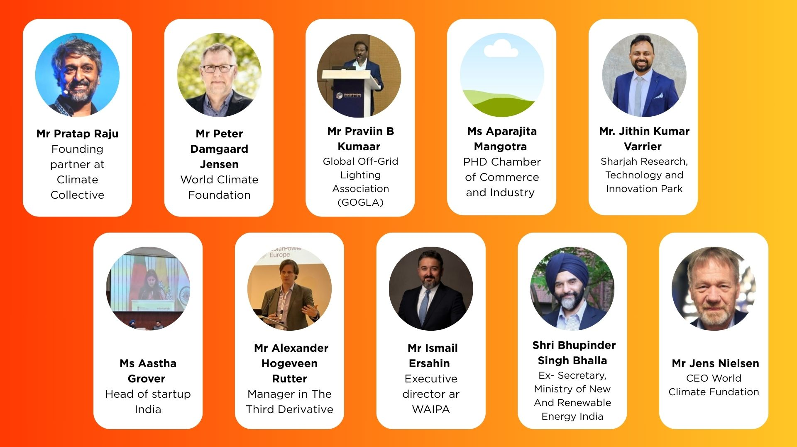



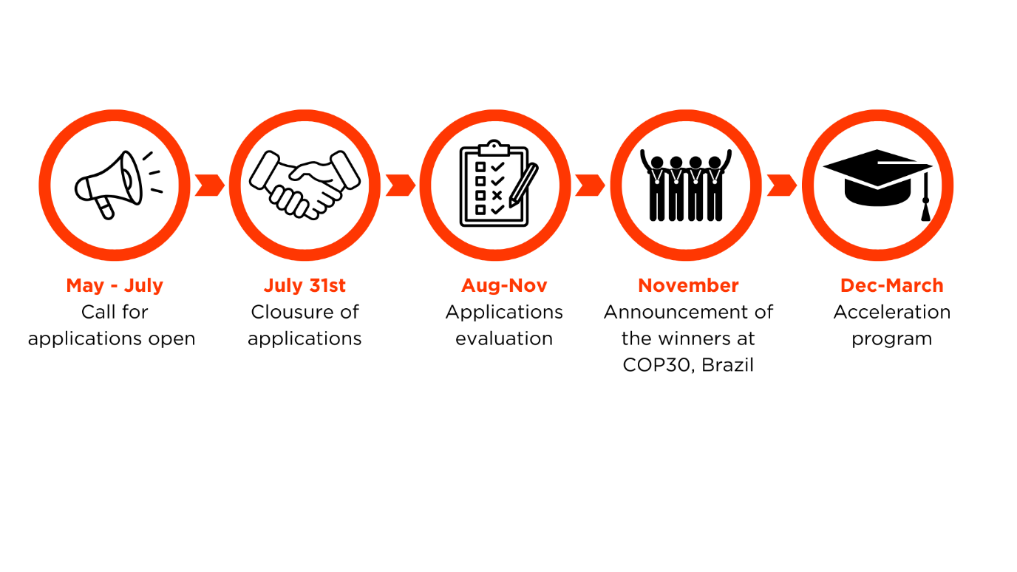

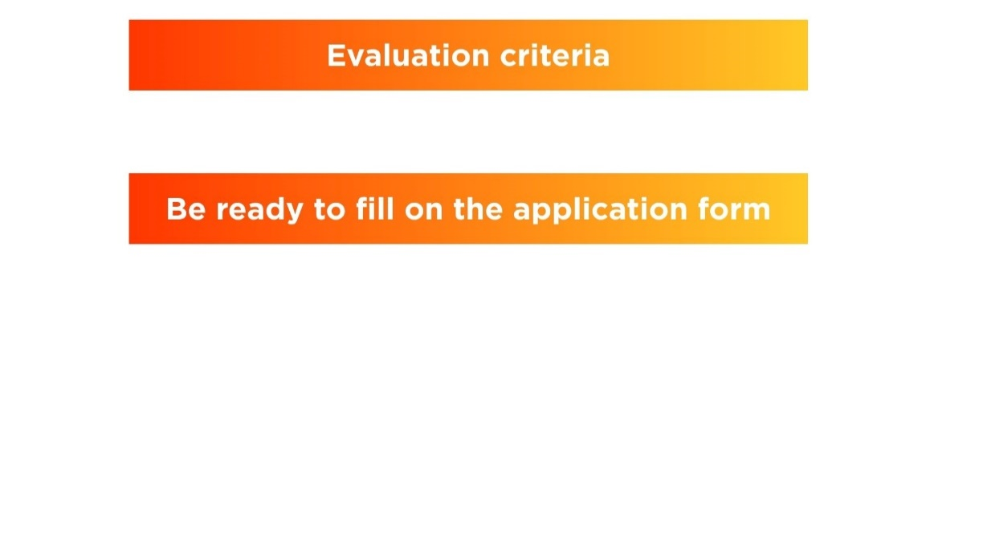

**These criteria are designed to identify startups that are not only innovative but also ready to grow, scale, and make a real impact in the LAC region.**

You will be evaluated by an international committee that will be looking for the aspects I’m about to mention, so make sure you are specific in including it when submitting your application.

* The **innovation** of your business model. Startups that bring fresh, creative, and scalable approaches to solar energy challenges.
* A clear and **differentiated value proposition** and your ability to deliver it through your solution (product/service) where solar energy is involved.You have identified a clear market segment for which your solution provides a solution to a specific challenge. ou have a clear market segment to whom you are solving a challenge with your solution.

* The **replicability** of your solution. Your solution or service can be replicated, adapted or scaled up across different countries and communities in Latin America, the Caribbean and beyond.
* **The strength of your team.** A capable, committed, and complementary team with the skills and experience to execute the vision. We want to see your passion, your track record, and how your team works together to bring your solution to life.
* **And your plan for using the grant.** A clear, strategic, and impactful plan for how you will use the $15,000 grant if selected.

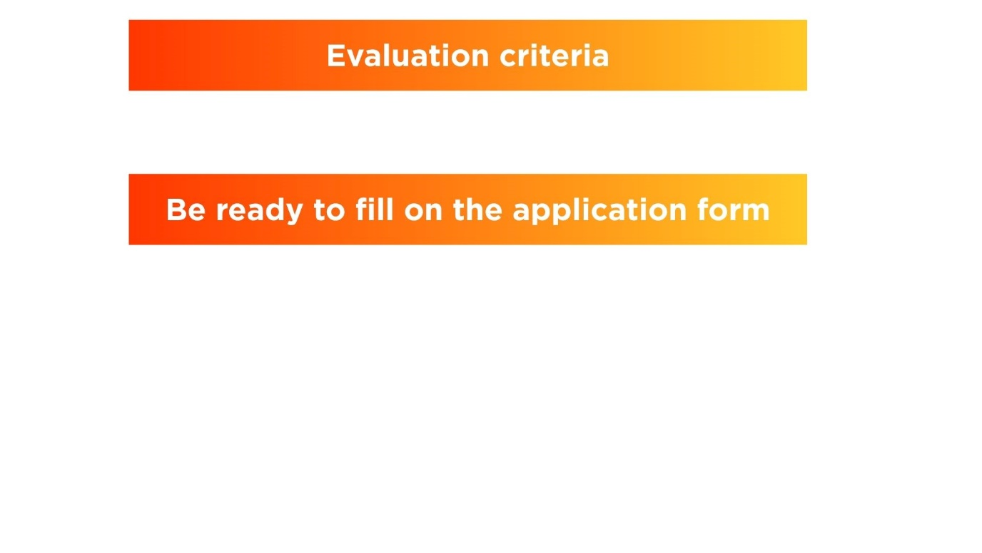

Prepare the following documents:

* Certificate of incorporation of your startup.
* A description of your solution and market.
* An image of your MVP.
* Your pitch deck. Include your roadmap and how you will use the 15.000 grant.
* Team bios and CVs.
* And financial statements from the last 3 years.

Visit **www.solarx.isa.int/resgistrationlac** and start your application



**We can go through with you to fill in the application form:**

[**solarxchallenge2025latam@isa.int**](mailto:solarxchallenge2025latam@isa.int)

*\*IDOM is the consulting firm in charge of executing the call for the LAC region*